***PART 1***

Bar Graph Visualizations:

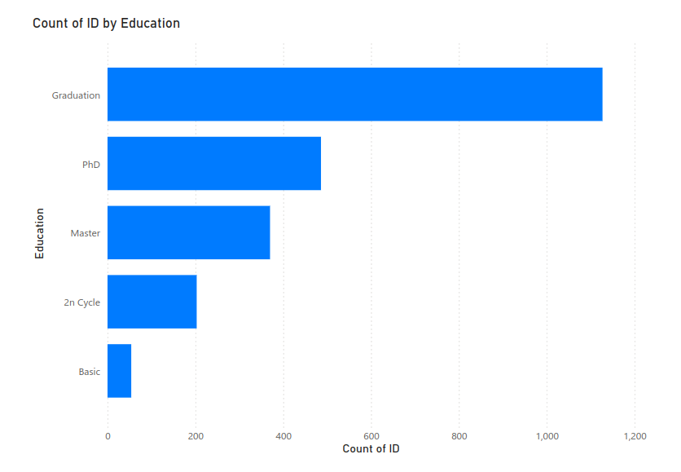

The bar graph indicates that the majority of customers have a "Graduation" level of education, with over 1,000 individuals falling into this category. In contrast, the number of customers with a "Basic" education is the smallest, highlighting a significant disparity in educational distribution.

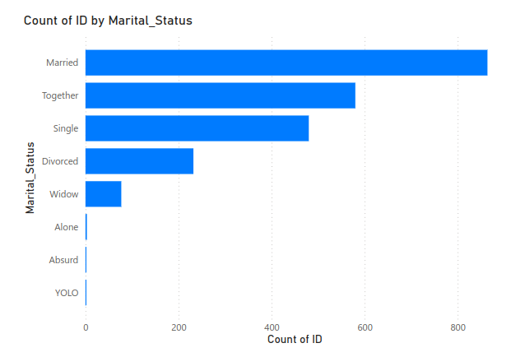

The bar graph indicates that more than 1400 customers are married or together and only around 800 are single individuals. This shows the trend that more couples in costumers

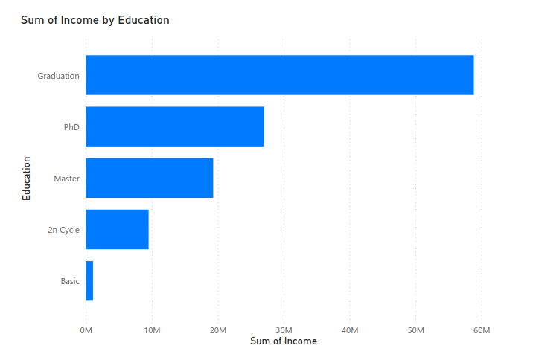

The bar graph shows that customers with a "Graduation" level of education have the highest total income, significantly more than the other education levels. In contrast, those with "Basic" education have the lowest total income, indicating a potential correlation between higher education and increased income.

***PART 3***

plt.scatter(Compact["x1"], Compact["x2"])

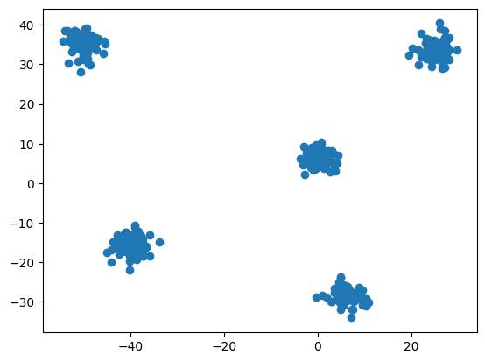

plt.scatter(Skewed["x1"], Skewed["x2"])

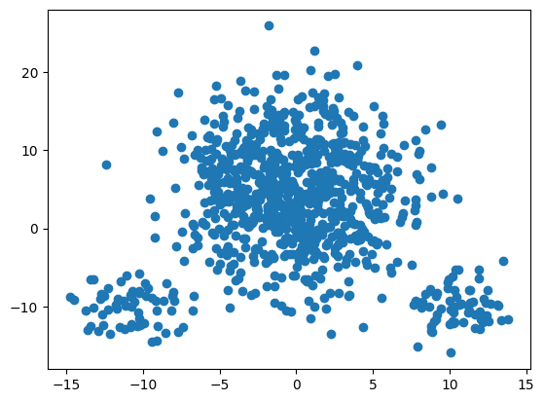

plt.scatter(Subclusters["x1"], Subclusters["x2"])

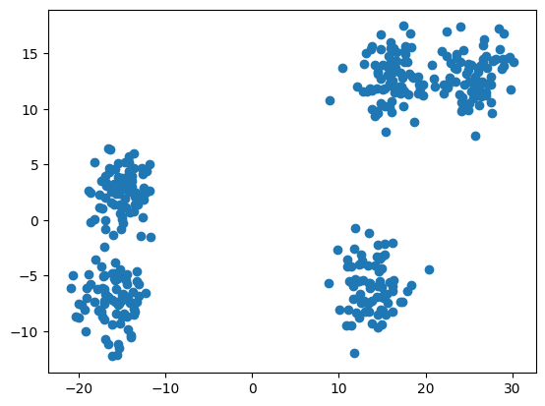

plt.scatter(wellSeperated["x1"], wellSeperated["x2"])

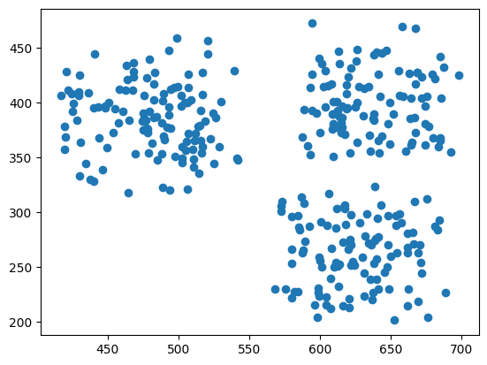

Elbow curves:  
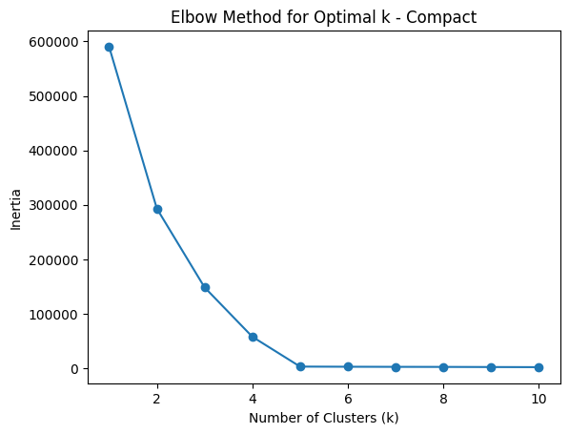

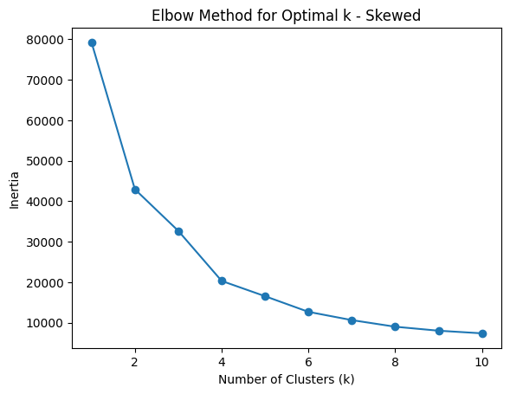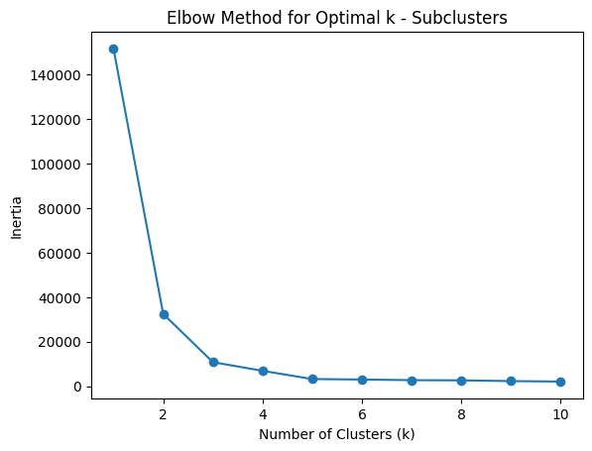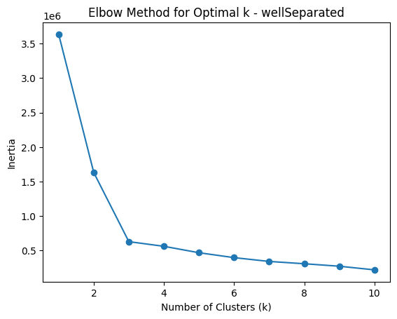

datasets = [Compact, Skewed, Subclusters, wellSeperated]

optimal_clusters_per_dataset = [5, 4, 4, 3]

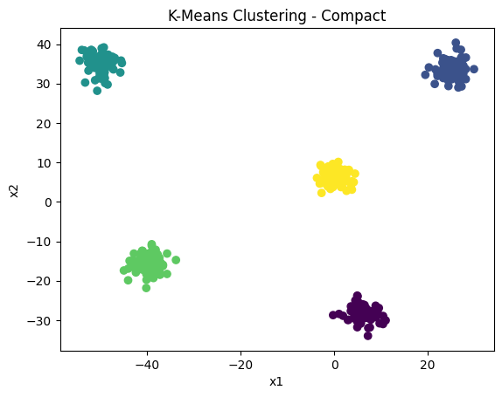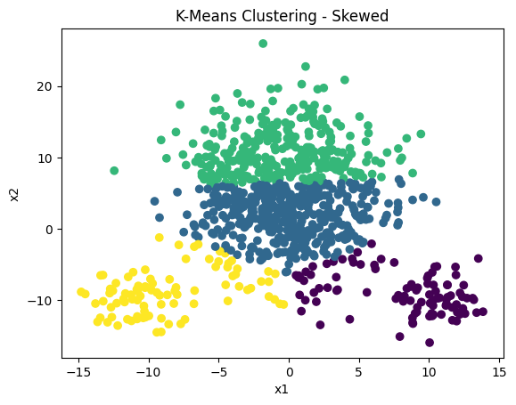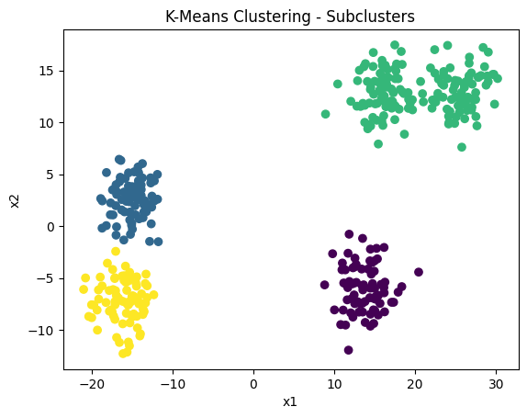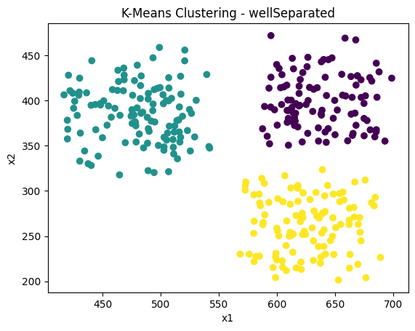

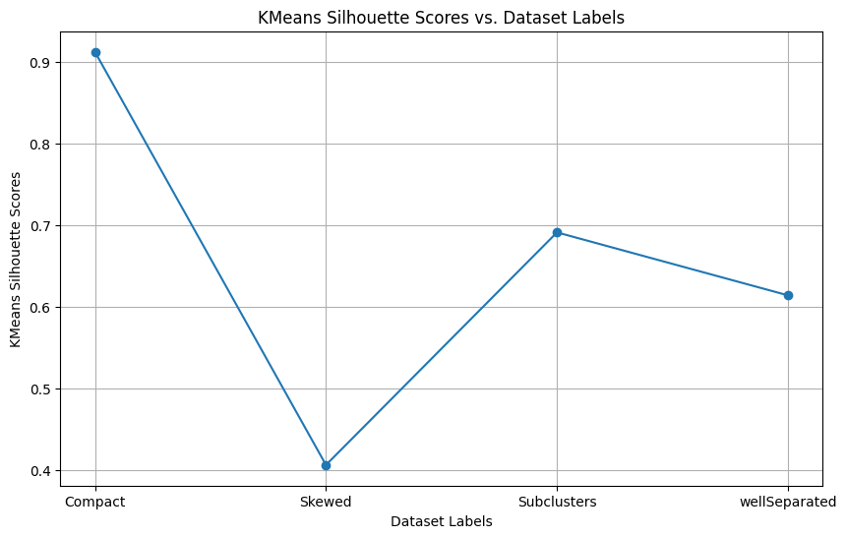

KMeans Clustering (Compact Data):

Clusters are spherical and equally sized so it is performing optimally.

KMeans Clustering (Skewed Data):

The algorithm fails in this case primarily due to its assumption that clusters are spherical and equally sized.

KMeans Clustering (SubClusters Data):

It assigns points to the nearest centroid, some more clusters could be created but arent, so it is performing sub-optimally.

KMeans Clustering (wellSeperated Data):

Works well as clusters are well-separated and have roughly equal sizes.

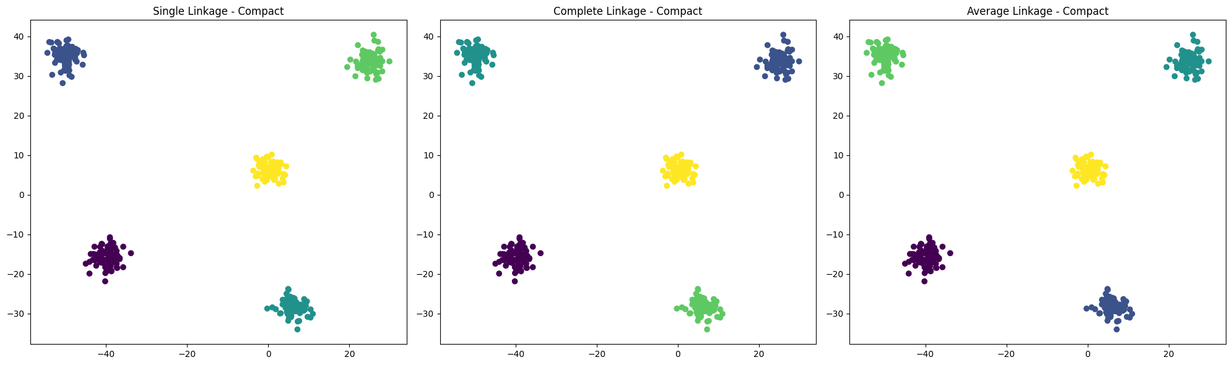

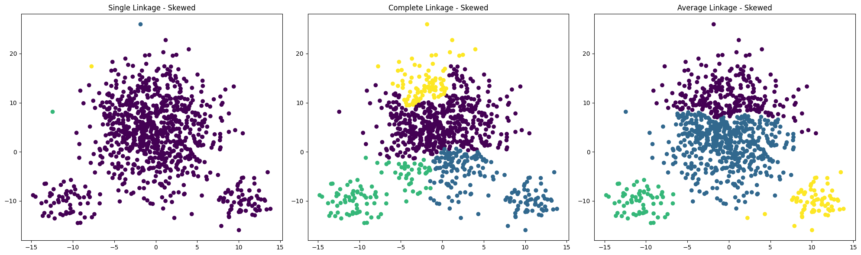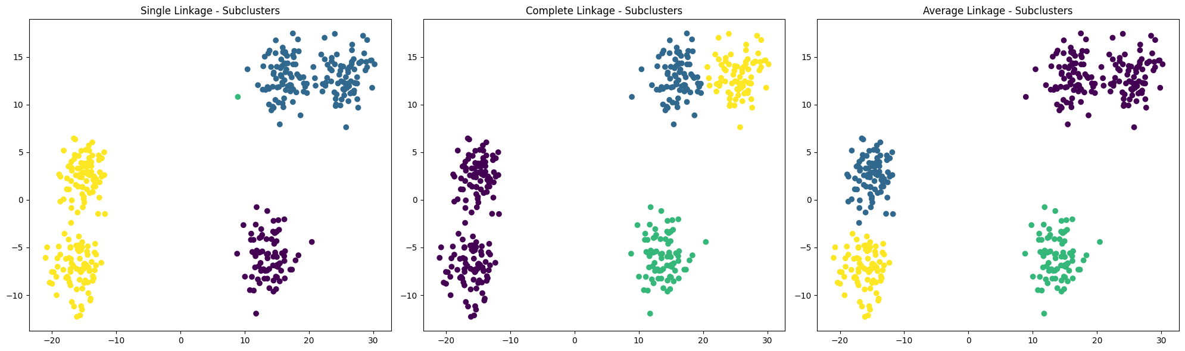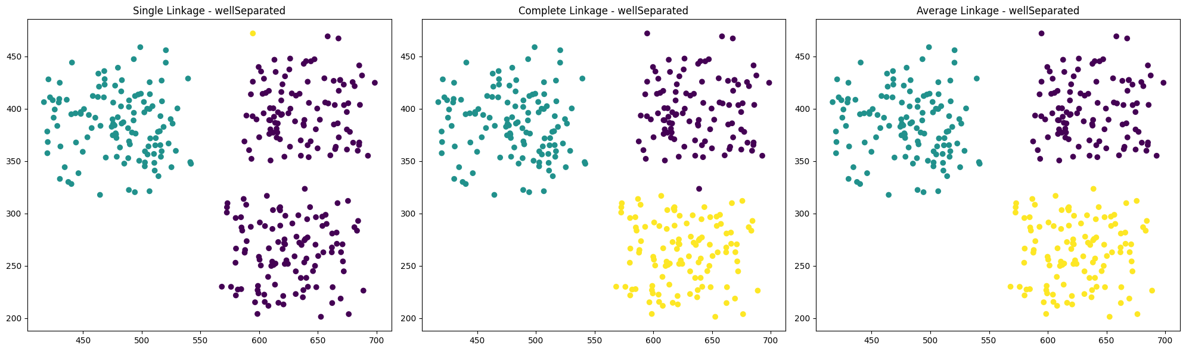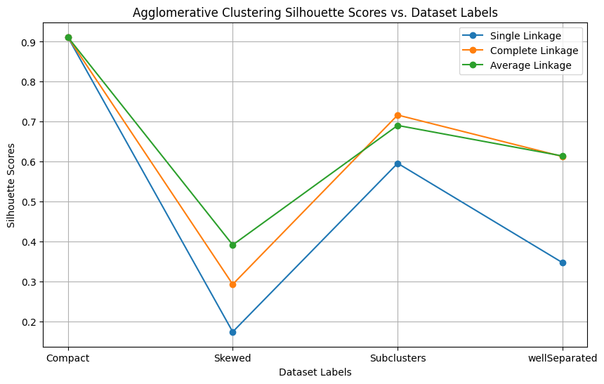

Aggloromative Clustering (Compact Data):

Works well especially with complete or average linkage, which consider the maximum or average distance between clusters, respectively.

Aggloromative Clustering (Skewed Data):

Similar to KMeans, it struggles with skewed clusters.

Aggloromative Clustering (SubClusters Data):

Works well especially if linkage strategies consider the average or complete distance between clusters.

Aggloromative Clustering (wellSeperated Data):

Performs well for well-separated clusters, especially with single or complete linkage.

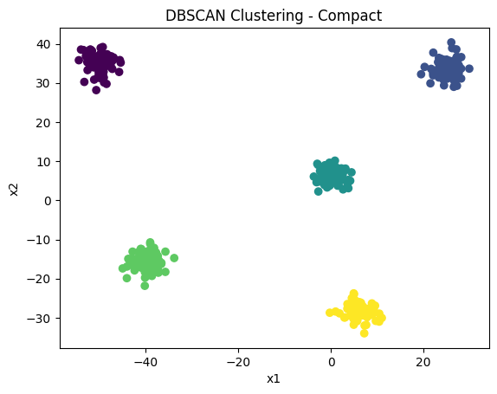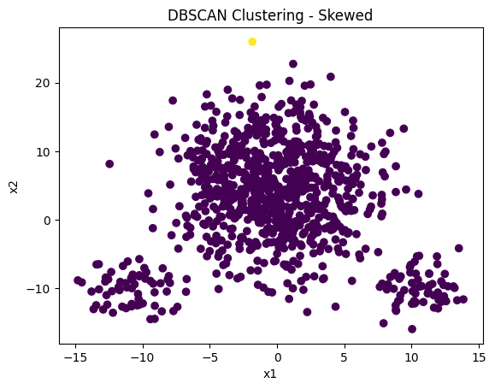

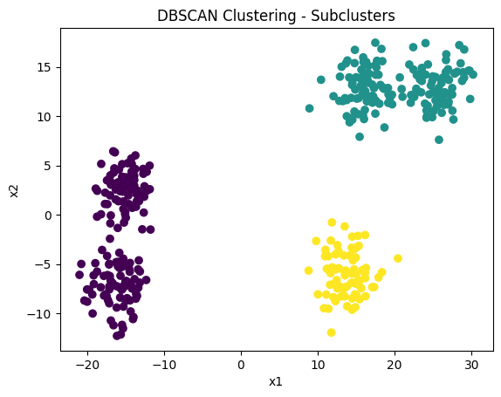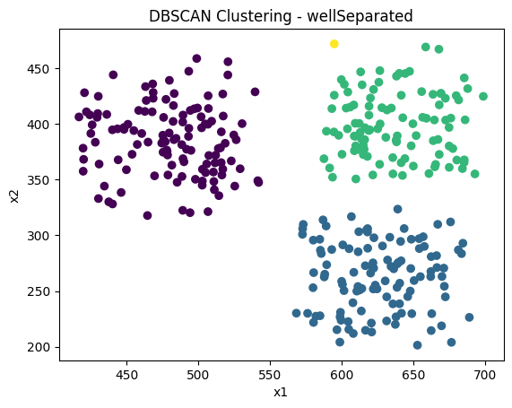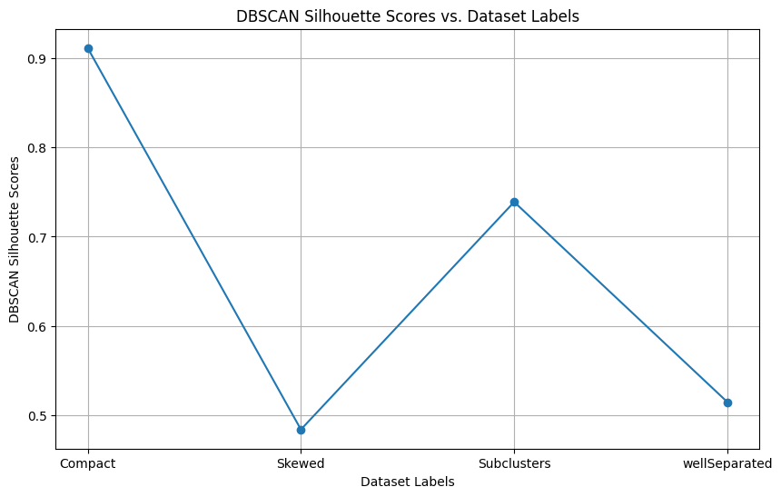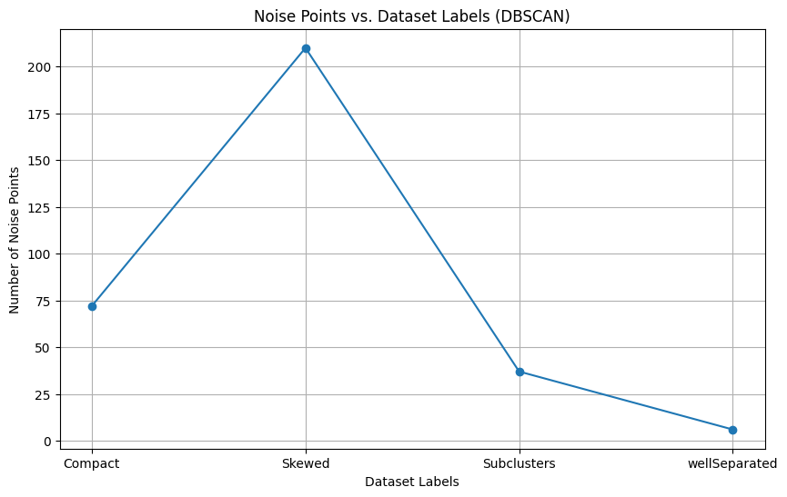DBSCAN Clustering (Compact Data):

Works well as the compact clusters have consistent densities.

DBSCAN Clustering (Skewed Data):

Works well and the algorithm can handle skewed clusters better than KMeans, as it doesn't assume any specific shape.

DBSCAN Clustering (SubClusters Data):

Performs well as subclusters have sufficient density, and parameter tuning is crucial.

DBSCAN Clustering (wellSeperated): May not be the best choice for well-separated clusters but the density of points within each cluster is sufficient so it's working well. Tuning parameters is crucial.

|  | **Dataset** | **K-Means** | **Agg.Lnk.Single** | **Agg.Lnk.Complete** | **Agg.Lnk.Average** | **DBSCAN** | **DBSCANNoisePoints** |
| --- | --- | --- | --- | --- | --- | --- | --- |
| **0** | Compact | 0.911780 | 0.911780 | 0.911780 | 0.911780 | 0.911780 | 0 |
| **1** | Skewed | 0.406510 | 0.173779 | 0.292751 | 0.391412 | 0.483642 | 10 |
| **2** | Subclusters | 0.690960 | 0.595697 | 0.716513 | 0.690470 | 0.738949 | 0 |
| **3** | wellSeparated | 0.613946 | 0.346804 | 0.612632 | 0.613946 | 0.514372 | 310 |

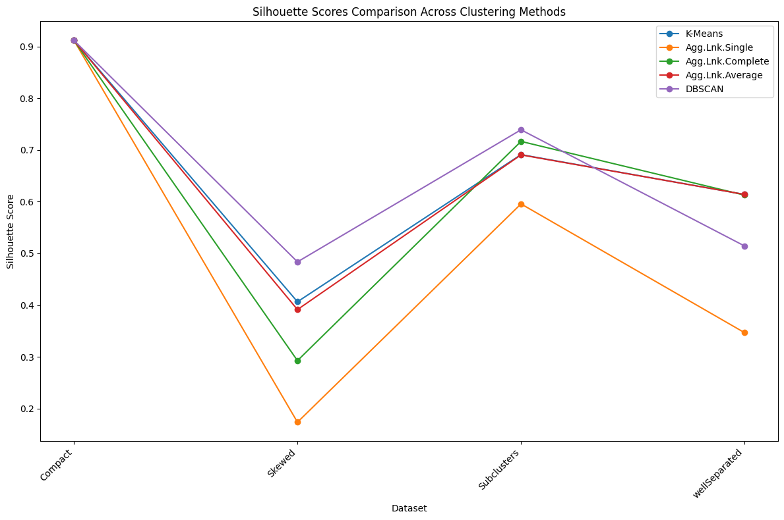DBSCAN Algorithm performs the best for almost each and every data.